**SINGAPORE POLYTECHNIC**

**SCHOOL OF COMPUTING**

SPECIALIST DIPLOMA IN WEB DEVELOPMENT TECHNOLOGY

DIPLOMA (CONVERSION) IN WEB AND PROGRAMMING

Module Code : ST4011

Module Name : Fundamentals of Web Development Technology

Acad Year/Semester : 2019/2020 Sem 1

Lecturer Name : Vincent Goh

**Student Name: Arkar Maung**

***Assignment Title*** ***:***  ***CA1 – Website planning & webpage creation***

**CA1 – Website planning & webpage creation**

**Type of website:**

SG Mobile is buy & sell mobiles, macbooks, iWatches & other devices. Following address is current SG Mobile’s webpage:

http://www.sgmobile.sg

**Current (7/May/2019) Status of SG Mobile website:**

This website has 5 pages. And I would like to re-design this website for the following reasons.

1. Overall design has fixed size, not responsive.
2. Logo is not found on website.
3. Background color & font color should be redesigned.
4. Navbar looks simple yet unclear.
5. *Footer* - suggest including address and how to contact.
6. In *Home tab* - has too much-repeated information and clutter.
7. In *Home tab* - layout must be makeover.
8. In *Home tab* - lack of pictures/ images.
9. In *Home tab* - user might confused how to buy online.
10. In *We selling tab* - this tab is currently shown Leave Message instead of products.
11. *Exporter tab* - should be redesigned log-in page and register page.
12. *Contact Us tab* - should be included proper addresses.
13. *Shopping cart* - needs to redesign and should be in separate website.

**Goals and objectives of redesigning website:**

* When user lands on this website, user instantly knows what the website is and what the website is doing.
* Within less than 1 scroll, users would be able to see our promotion section if user intends to buy.
* Search icon/box and shopping cart would be visible to user all the time and gives clear information.
* Display quality images of product in order to provide precise information.
* Our website would be responsive in different size of screens.
* Background color and fonts would be balanced and uniformed.
* Navbar would be easy to understand and clean look.
* Address & contact number would be shown at footer of all pages, so that user will not get lost and knows who/how to contact.

**Target audience:**

Target audience would be between age of 20 to 50, who are currently in Singapore. Target audience in details are discussed below:

1. Product Focused Shopper:

This type of shoppers knows exactly what to buy and they might visit our website to straight-away search whether the items they want are available.

* We are going to provide a visible search icon or search bar, and available all the time on top-right corner, just beside shopping cart.

1. Browser:

This type of shopper is just browsing to kill their time. For instance, they would browse when they are waiting for public transport, etc.

* We are going to display our well-designed pictures/images of products on Home page which might lead to an unexpected sale.

1. Researcher:

- These types of shoppers are buying a product, but they are confused which brand to choose.

* We are going to display at least 3 pictures/images for close-up look, a complete product description, product details and price at an individual product page.

1. Bargain Hunter:

This type of shoppers would like to see products on sale.

* We are going to provide a promotion section at home page just after welcome image.

**Colors (use in website):**

* Red (for promotion items & headers in order to be visible quickly).
* Grey (for texts which are not important for every users).
* White & Black (for clean look and spaces between layouts).

**Theme:**

* Different shades of blue (as SG Mobile Logo is made from these colors).

**Fonts:**

* A font like hand-writing feature (for styling eye-catchy contents).
* A font which is easy to understand yet different (for navbars, headers & footers).

**Approximate Budget for the project:**

|  |  |  |  |
| --- | --- | --- | --- |
| *Item* | *Basic* | *Advance* | *Enterprise* |
| Domain Name | S$12/yr | S$12/yr | S$12/yr |
| Hosting | S$20/mnth | S$350/mnth | S$1000/mnth |
| Email | Free with hosting | S$5-S$25/user | S$5-S$25/user |
| Front End Development | S$2000+ | S$8000+ | S$35000+ |
| Back End Development | S$2000+ | S$8000+ | S$50000+ |
| eCommerce | S$3000+ | S$8900+ | S$50000+ |
| Total: | S$7320+ | S$17287+ | S$136037+ |

**Timeline for the project:**

***(13May2019 - 19May2019)***

1. Navbar
   * Dropdown (mobile view)
   * Navbar (Laptop view)
   * Search icon/box
   * Shopping Cart
2. Fonts
   * Choose fonts & download
3. Photo
   * Searching:
   * Resizing:
   * Enhancing:

***(20May2019 - 26May2019)***

1. Home Page
   * Choose a Welcome photo - in HomePg-sec1
   * Promotion items group and show 4-items, More Button to link to another page - in HomePg-sec2
   * Mobile Phones group and show 6-items, More Button to link to another page in HomePg-sec3
   * Macbooks group and show 6-items, More Button to link to another page in HomePg-sec4
   * iWatches group and show 6-items, More Button to link to another page in HomePg-sec5
   * Condition Check for sell product page
   * Footer-1 - Address & Contact
   * Footer-2 – Copyright

**(27May2019 - 09June2019)**

1. Products - Phones
   * Title - in Product-Phone-sec1
   * Plan layout for items - in Product-Phone-sec2
   * Place attractive product images in respective layout - in Product-Phone-sec1
   * Footer-1 - Address & Contact
   * Footer-2 - Copyright
2. Products - Macbooks
   * Title - in Product-Macbooks-sec1
   * Plan layout for items - in Product-Macbooks-sec2
   * Place attractive product images in respective layout - in Product-Macbooks-sec1
   * Footer-1 - Address & Contact
   * Footer-2 - Copyright
3. Products - iWatches
   * Title - in Product-iWatches-sec1
   * Plan layout for items - in Product-iWatchese-sec2
   * Place attractive product images in respective layout - in Product-iWatches-sec1
   * Footer-1 - Address & Contact
   * Footer-2 - Copyright

**(10June2019 - 21June2019)**

1. Login
   * Plan layout for login page
   * Login title - in Login-sec1
   * Form: username, password, Login button, remeberMe - in Login-sec2
   * Link Register Now button in Login Pg to Register page - in Login-sec2
   * Footer-1 - Address & Contact
   * Footer-2 - Copyright
2. Register
   * Plan layout for register page and must be similar to login page for balance effect
   * Register title - in Register-sec1
   * Form: username, email, password, confirm password, register button, accept terms & conditions- - in Register-sec1
   * Footer-1 - Address & Contact
   * Footer-2 - Copyrigh
3. About Us
   * Plan layout for about us
   * What we are selling, why you should buy from us, why you should sell to us
   * Operation hour
   * Address (prefer a map)

**Structure of Milestone**

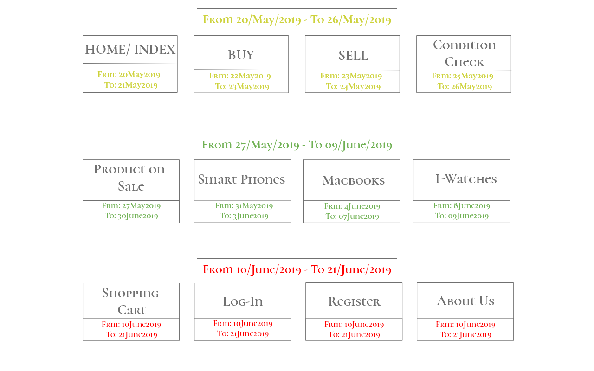

**Structure of sitemap**

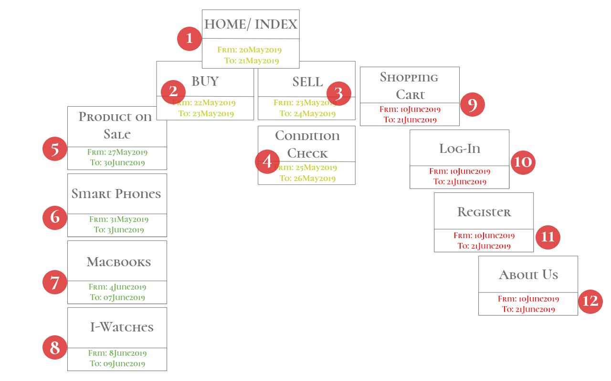

**Some Wireframe screens – Index & Index Drop down bar**

Let user to choose whether they want to buy or sell, by clicking the 1st pic as shown below. There is a drop down menu under product.

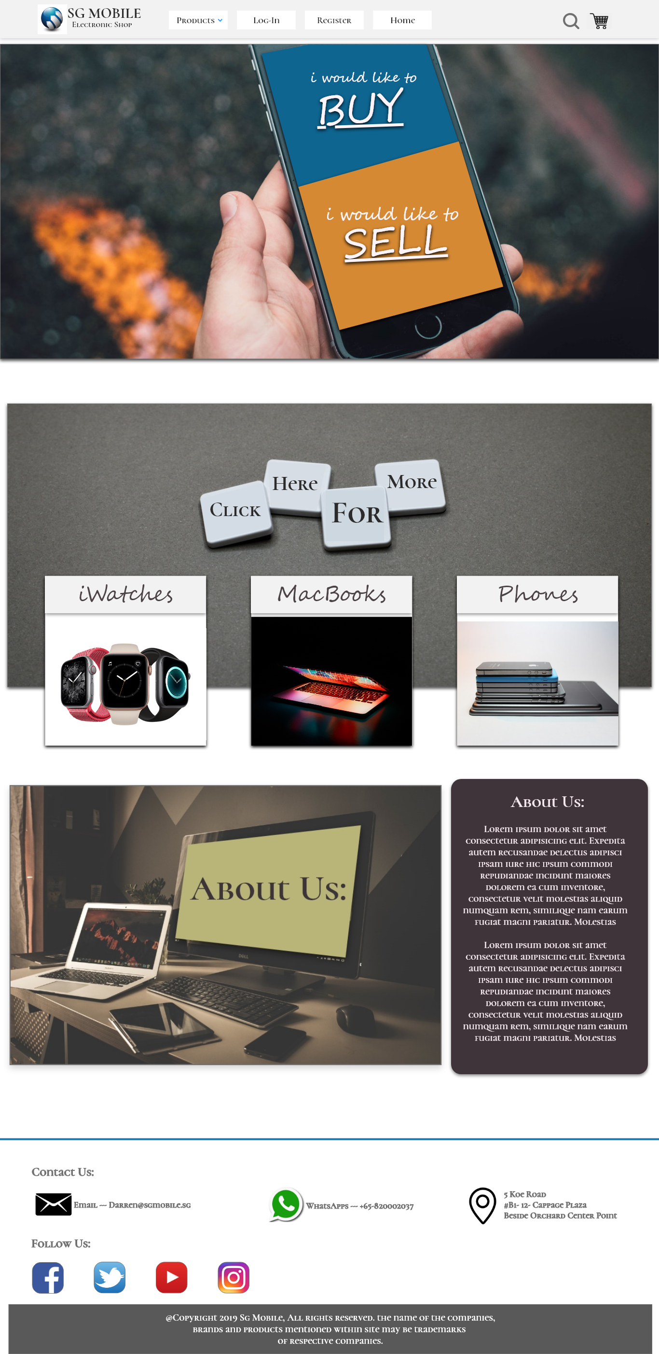 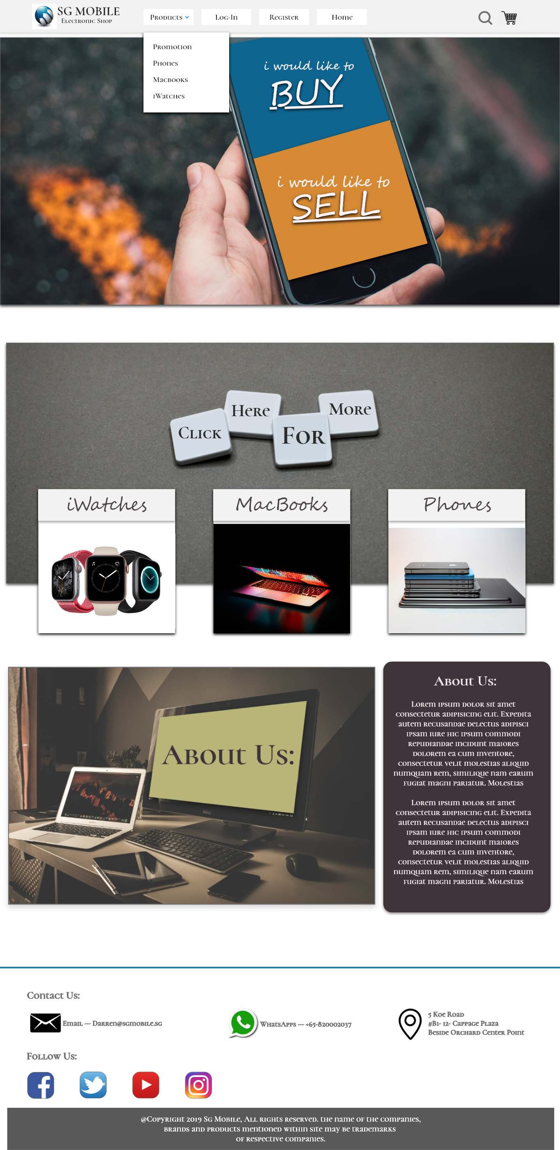

**Some Wireframe screens – Buy Page**

User will be on this page if “i want to buy” button is clicked.

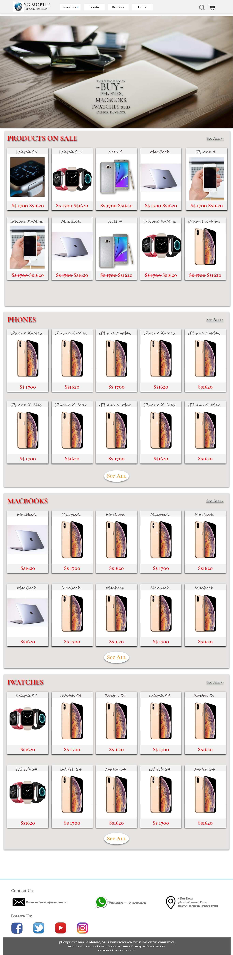

**Some Wireframe screens – Item details after user click from buy page**

User can click on any item he/she is interested in. And it will bring user to detail page as shown below:

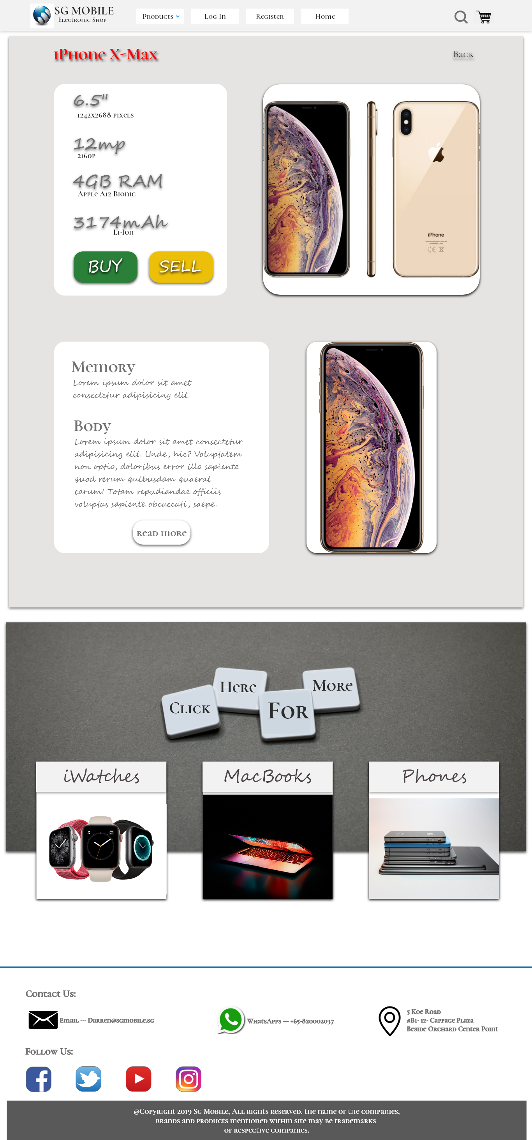

**Some Wireframe screens – User needs to choose options for the item**

User choose to click buy button, this modal will pop-up and let user to choose which memory, color, quantity, etc., of the item they select.

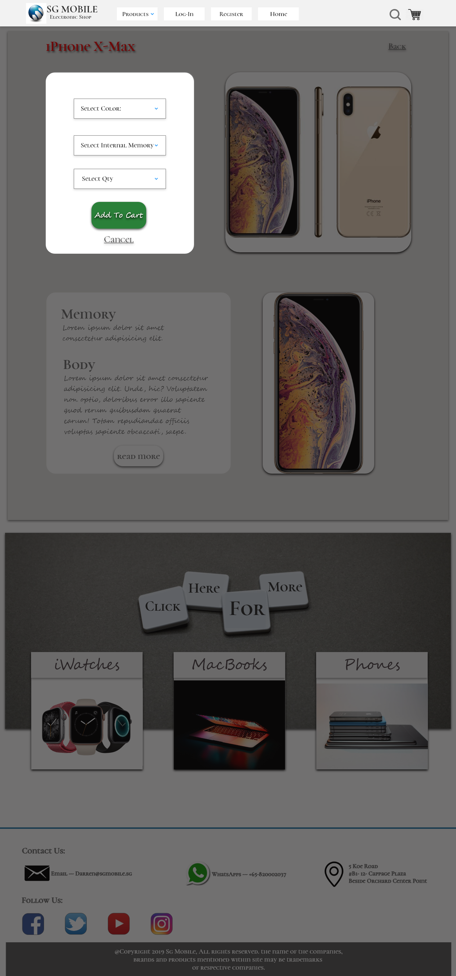

**Some Wireframe screens – Shopping Cart**

When user decided to check-out, this is the shopping cart page

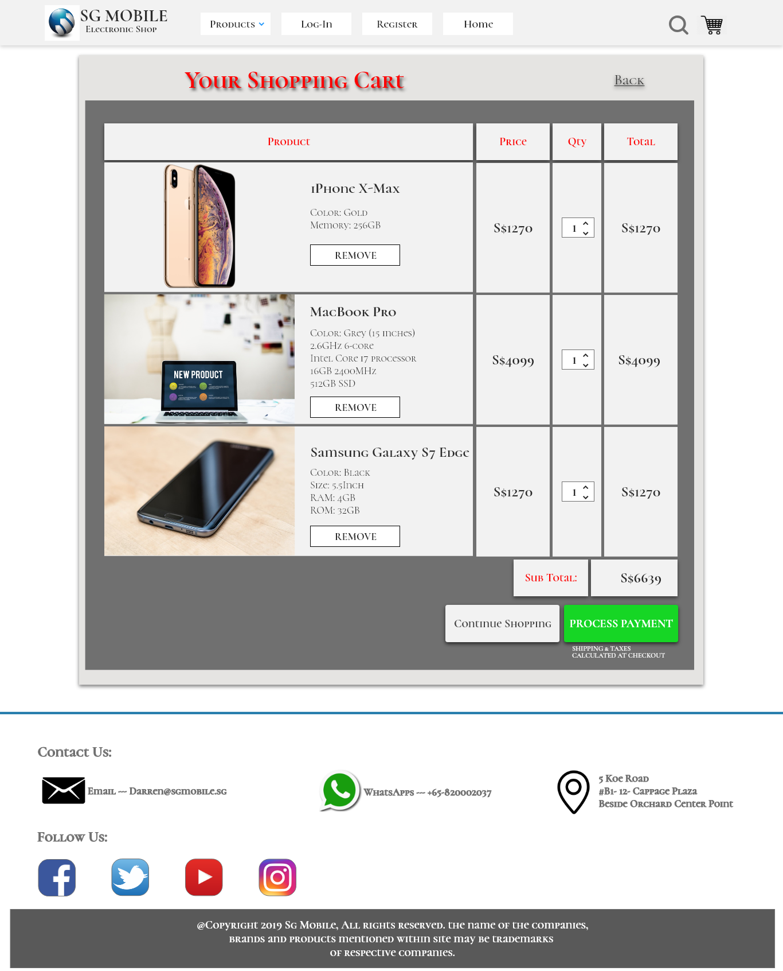

**Some Wireframe screens – Sell page**

User would be brought to “i want to sell” page when they click sell button.

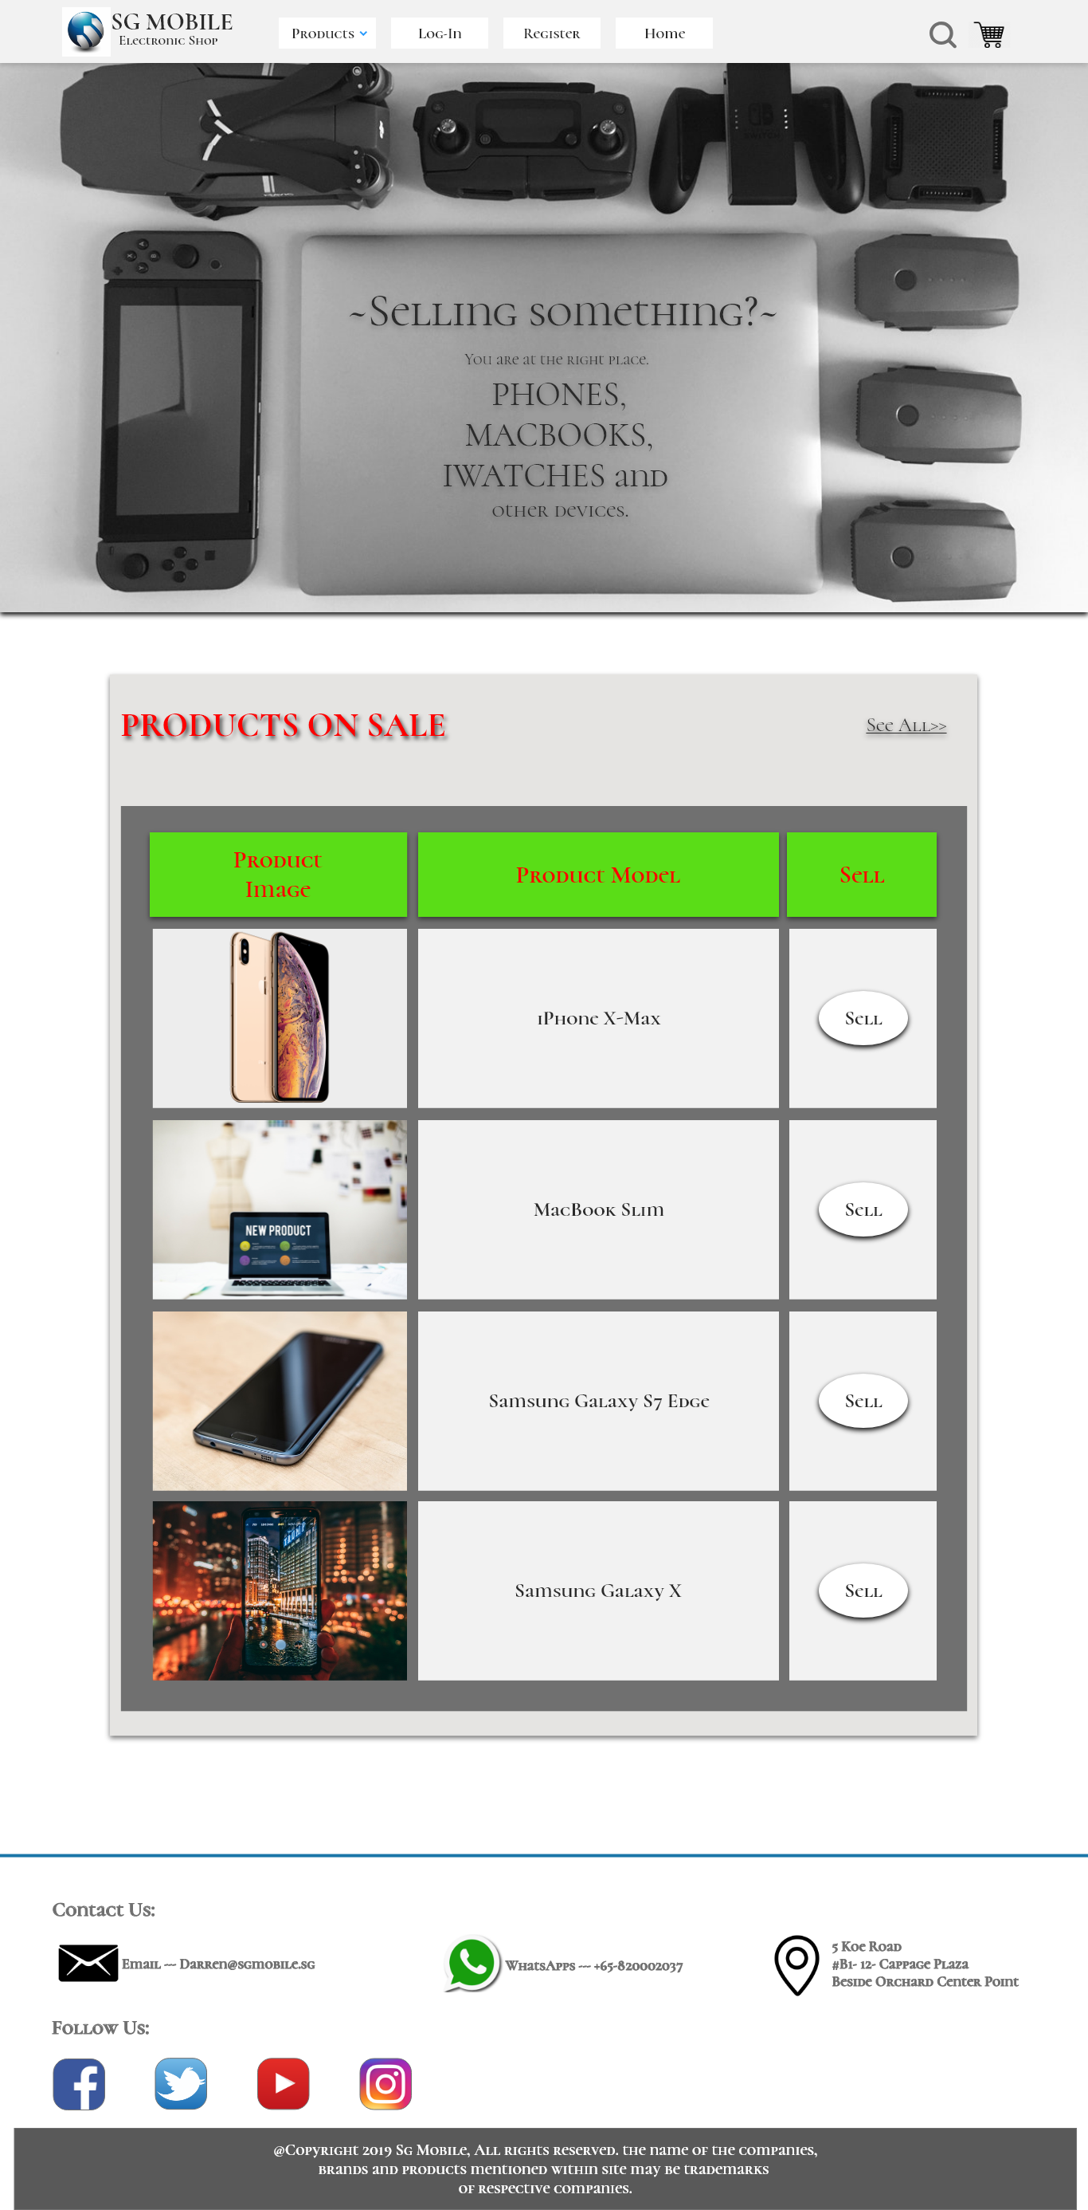

**Some Wireframe screens – Sell button is pressed.**

If user clicked "sell” button from the selling list, this modal will pop-up and ask about their products’ particular.

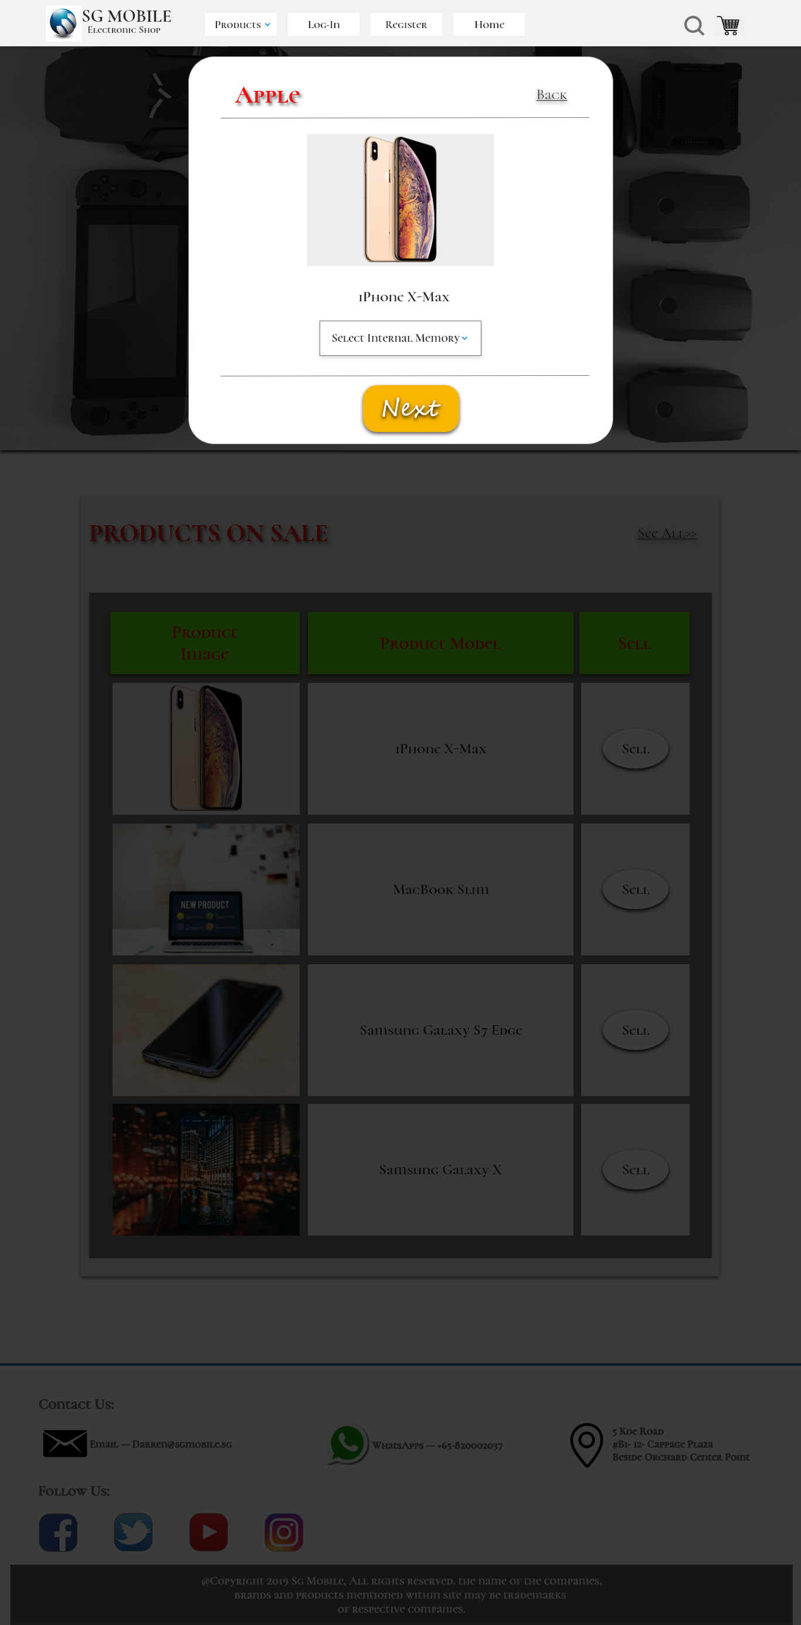

**Some Wireframe screens – Sell button is pressed.**

If user click “Next”, it will bring user to another question page about products’ particular in more detail.

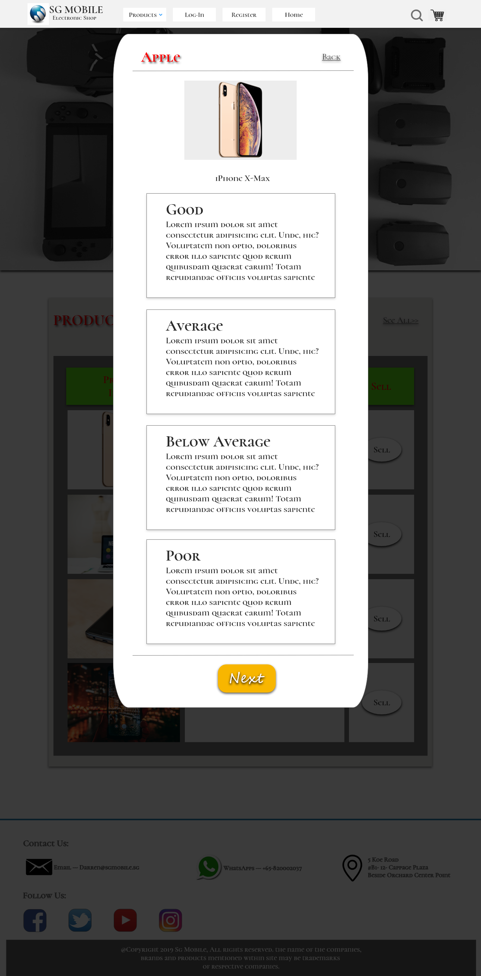

**Some Wireframe screens – Sell button is pressed.**

Final step will be a form that user needs to fill-up and meet up for physical check of the item they would like to sell.

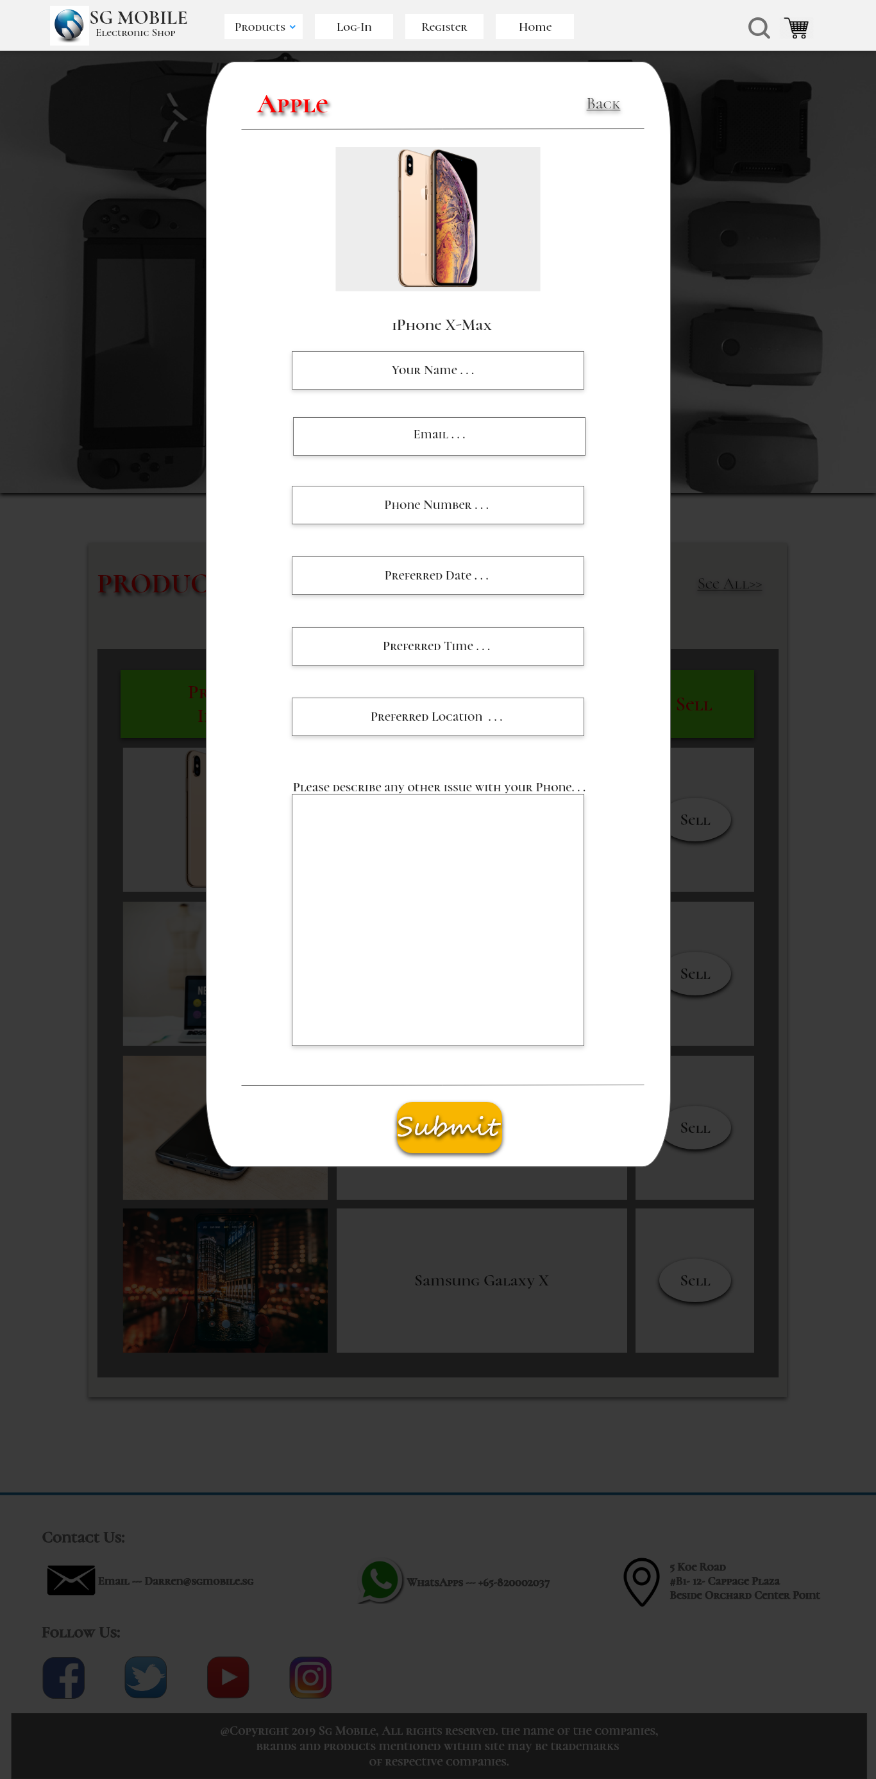

**Some Wireframe screens – Log-In & Register**

Login & Register tabs are also available upon SG Mobile’s request.

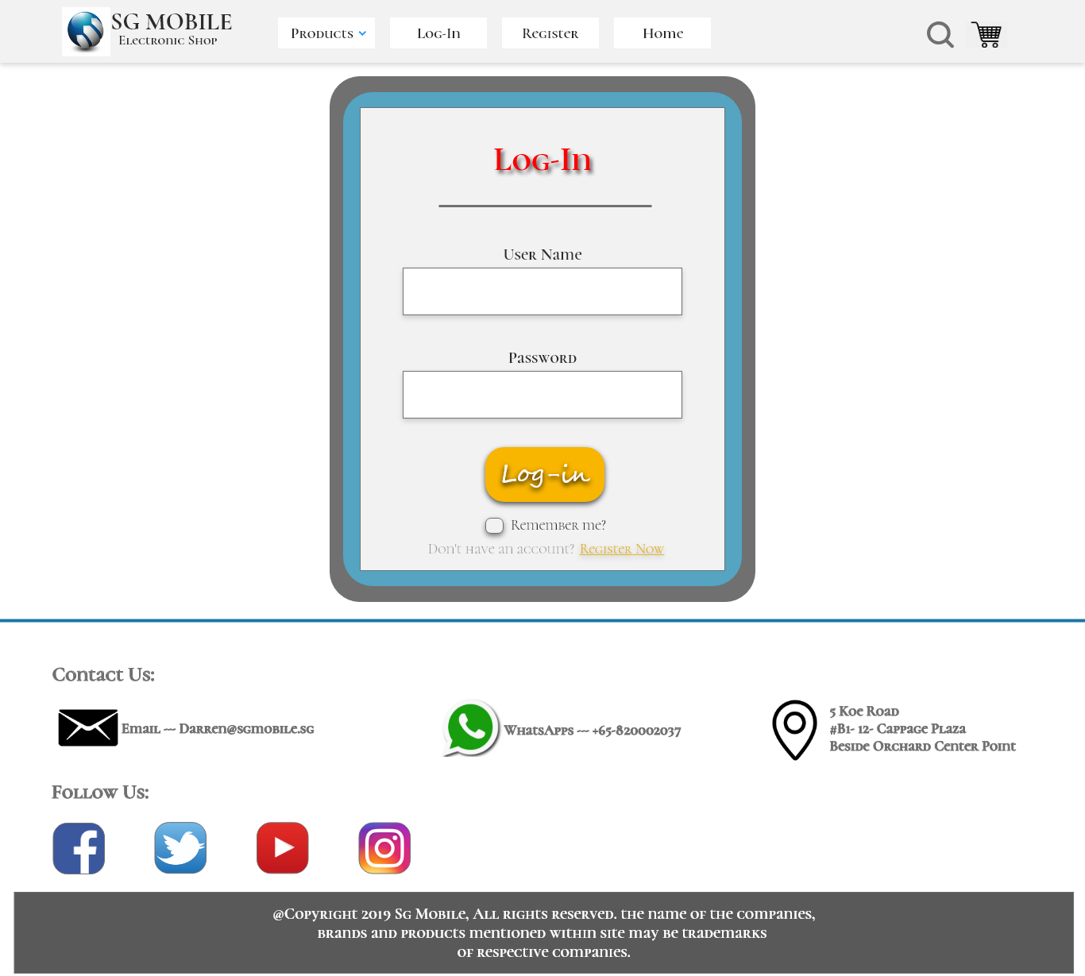

**Some Wireframe screens – Register page scratch while using HTML5 tags**

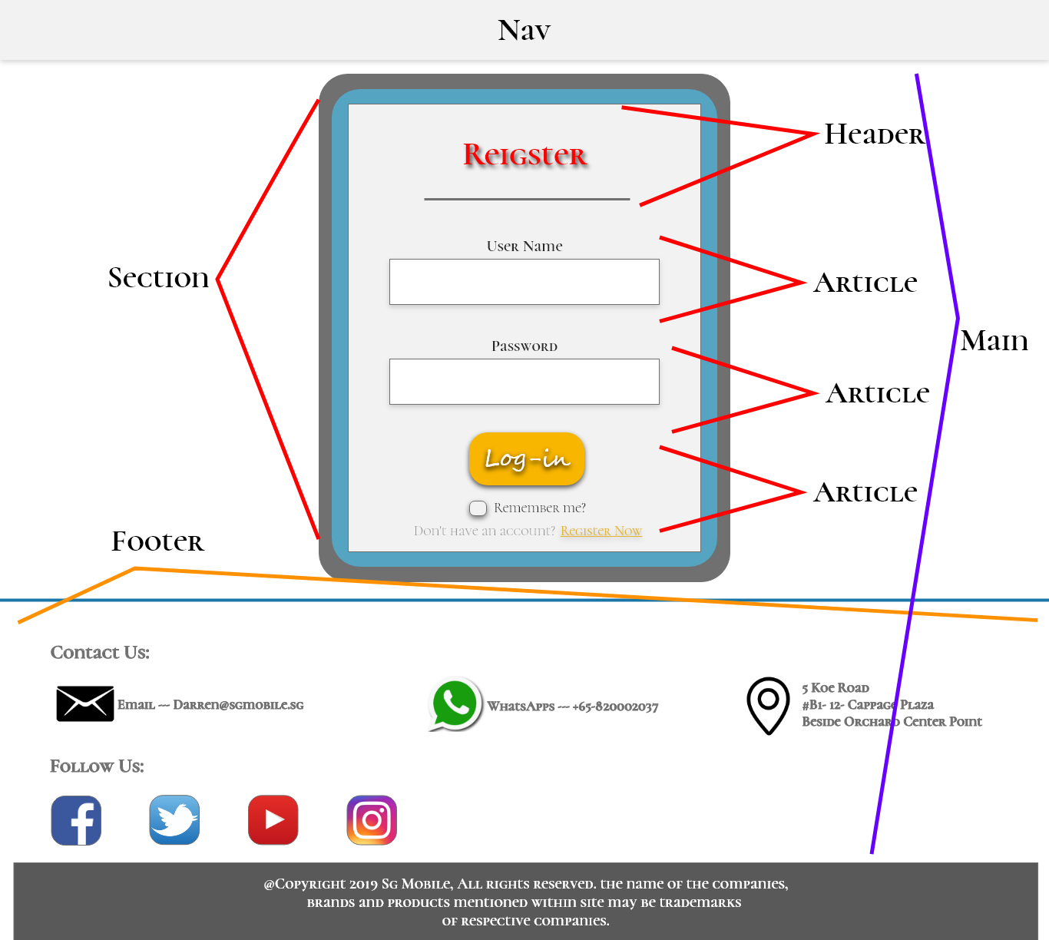

**Some Wireframe screens – Register page**

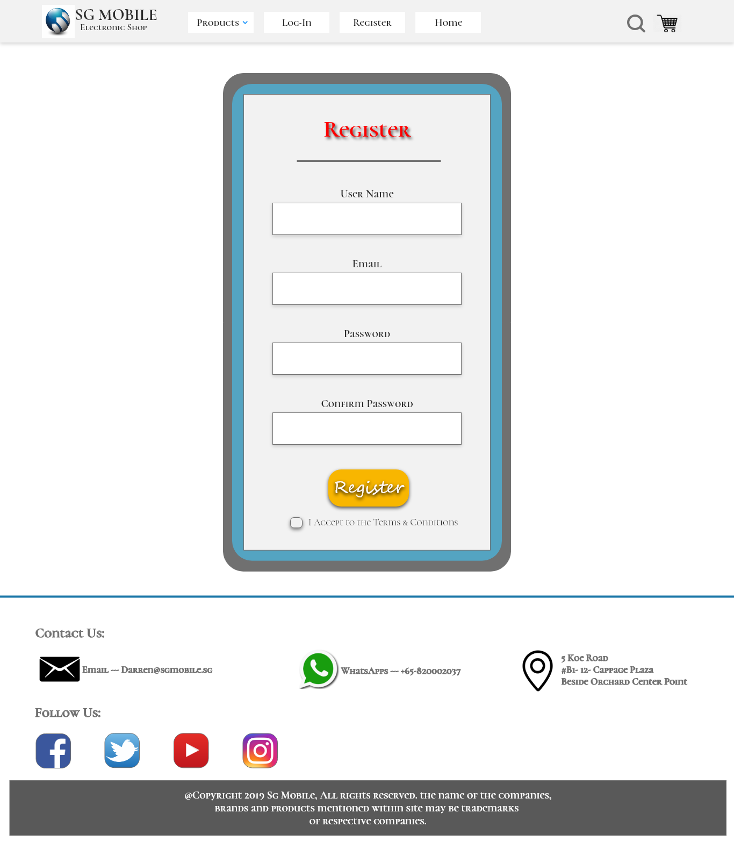

- End -